5.126: In all cases, the tension in the string will be half of F.
a) 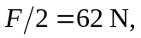 which is insufficient to raise either block; 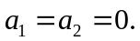
b) 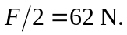 The larger block (of weight 196 N) will not move, so 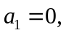 but the smaller block, of weight 98 N, has a net upward force of 49 N applied to it, and so will accelerate upwards with 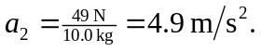
c) 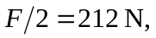 so the net upward force on block A is 16 N and that on block B is 114 N, so 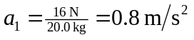 and 